**TITLE**

Exploring the mechanisms underlying diverse response to climate change in marine ecosystem models

**ABSTRACT**

The global marine ecosystem is exceedingly complex, and many gaps remain in our process understanding. Yet, the rapid changes being wrought by climate change demand that we attempt to quantify and project its outcomes, in order to motivate climate change mitigation, provide foresight for potential food security threats, and identify needs for adaptation. Thus, recent years have seen a proliferation of grid-based marine ecosystem models that simulate animal biomass and ecosystem structure at the regional and global scale, driven by output from climate-biogeochemical models. However, there is a lack of clarity in how physical-chemical changes projected by climate models are filtered through the heterogenous designs of marine ecosystem models. Here, we explore the mechanisms driving the response of nine global and three regional marine ecosystem models to two key climate drivers—lower trophic level production (LTLP) and temperature—to better understand the sources of variation in marine ecosystem model responses to climate change, and pinpoint the most important process uncertainties in need of further observational constraints. Impacts of changes in LTLP and temperature on animal biomass and ecosystem structure were isolated in an experimental protocol, in which models were forced with a combination of pre-industrial and climate change (historical and RCP85) LTLP and temperature forcings from the CESM1-BGC earth system model. We find that there is broad agreement across models that animal biomass decreases with increasing temperature and decreasing LTLP, and that these impacts are amplified for large animals. However, there remains significant uncertainty in the magnitude of these changes, revealing the disparate assumptions and uncertainties across models with respect to how temperature and LTLP affect processes at the individual and ecosystem level. We finish by summarising the key gaps in our understanding of how climate change will drive shifts in processes from individuals to ecosystems, as well as the use of emergent constraints to set boundaries on marine model projections of climate impacts.

**STRUCTURE OF RESULTS**

1. A review of the mechanisms that incorporate LTLP and temperature in each model. This review will summarise the mechanisms for temperature and LTLP separately, but with the same question for each:
2. How does LTLP/temp. drive the balance between the creation and destruction of biomass at the individual level in this model?
3. How does LTLP/temp affect the structure of the ecosystem in this model?
4. Changes in total animal biomass across models and simulations
5. Changes in biomass of <30cm and >30cm animals across models and simulations
6. Compare model projections of total animal biomass with Free et al., (2019) data. This will motivate discussion of one of the ways forward using emergent constraints.

We find that how npp and sst inputs are incorporated in models is the primary driver of variation in marine model climate projections at the global scale, and that we can group the response of different models together that share similar mechanisms and npp/sst inputs. Overall climate change impact is almost a linear combination of npp and sst changes for all models and where non-linearity is present it can still be mostly explained by npp and sst mechanisms. Trophic interactions and other model components play only a secondary role to npp and sst impacts.

**INTRODUCTION**

Climate change projections for marine living resources are important, however we lack an understanding of how they are filtered through the lenses of individual models and sources of variation between models. Need for ensemble model projections and an understanding of mechanisms that drive uncertainty in global model projections.

Animal biomass models are driven by earth system models, most common input variables are lower trophic level production and temperature.

BIG QUESTIONS FOR BOTH:

How does temperature and npp affect i) individual-level processes and ii) community structure

What role does lower trophic level inputs play in the marine ecosystem? Lower trophic level inputs such as net primary production fuel the entire marine food web. More lower trophic level biomass and production means more higher trophic level biomass. Food chain length is also sensitive to size of lower trophic levels. This is because marine ecosystem is strongly size-structured. This means in low productivity areas, average producer size is smaller, which means longer food chains and less efficient transfer of energy to organisms of a given size.

What role does temperature play in the marine ecosystem? At the most fundamental level, temperature drives chemical reaction rates within organisms. This in turn drives individual physiological rates such as feeding, respiration, reproduction etc. At the level of the individual the effect of temperature mainfests at the level of creation/destruction of new biomass, and at the food web level, the flux of biomass through trophic levels. The balance between the creation/destruction of new biomass is unclear. Depends on species, and their thermal niche; temperature drives changes in composition of species. At a more aggregated level, looking at the overall production of a system, the balance between creation and destruction of new biomass at different temperature rates depends on community-level physiological response. General understanding is that destruction of biomass outpaces creation of new biomass as temperature increases, as energetic demands of maintenance of existing biomass reduces scope for growth and reproduction.

However, how npp and temperature processes play out is unclear, which is reflected in the lack of consensus in marine models, unlike other modelling areas.

Use of emerging constraints.

In this paper, we identify the mechanisms that drive variability in the response of xx marine ecosystem models to changes in lower trophic level and temperature inputs.

**METHODS**

**Model mechanisms**

Overview of modellers survey, to show how we identified and categorised processes in each model that are affected by npp and temperature.

Give a summary of what terms such as ‘growth’, ‘mortality’, ‘reproduction’ etc mean. Summary table of models, what parts of the marine ecosystem are they representing, body size range etc. Could we do this as a figure/s?

**Experimental protocol**

To isolate the response of the eight global MEMs to changes in lower trophic level and temperature environmental drivers, each model ran four simulations in which drivers were modified in different combinations of pre-industrial and climate-change forcings:

*No change:* Pre-industrial forcings are used for all drivers for the entire simulation period.

*Temperature change:* Pre-industrial forcings are used for all drivers for the entire simulation period, except for temperature-related drivers. For these drivers, historical forcings are used up to the end of 2005, before switching to RCP85 drivers from 2006-2100.

*Lower trophic level change:* Pre-industrial forcings are used for all drivers for the entire simulation period, except for lower trophic level-related drivers. For these drivers, historical forcings are used up to the end of 2005, before switching to RCP85 drivers from 2006-2100.

*All change:* Historical forcings are used for all drivers up to the end of 2005, before switching to RCP85 for all drivers from 2006-2100.

We defined lower trophic level drivers as any input forcings related to lower trophic levels, such as phytoplankton biomass and production, export production and zooplankton biomass. Similarly, temperature drivers were defined as any input forcings related to water temperature, which included 2-D variables such as the sea surface, bottom or average temperature over some or all of the water column as well as 3-D resolved temperature over some or all of the water column.

The eight MEMs that participated in the protocol require a range of temperature-related, lower trophic level-related and other environmental drivers (Supplementary Table 1). To obtain the required drivers, we reviewed the three CMIP5 models (GFDL-ESM2M, IPSL-CM5A-LR and CESM1-BGC) highlighted by Tittensor et al., (2018) as suitable for Fish-MIP. For our experimental protocol, input models needed to provide all required environmental drivers at a monthly time-step from 1860-2100 for pre-industrial, 1860-2005 for historical and 2006-2100 for RCP85. Of the three CMIP5 models determined suitable by Tittensor et al., (2018), only CESM1-BGC met these requirements.

**Output data**

Depth-column integrated, four outputs (tcb, b10cm, b30cm), reported as gC m-2 on 1x1 global grid squares. Native biomass and conversion coefficients used by each model are reported in Supplementary Table 2

**RESULTS**

**Model mechanisms**

**Table 1** Summary of processes that are affected by temperature in each model

|  |  |  |  |  |  |  |  |  |  |
| --- | --- | --- | --- | --- | --- | --- | --- | --- | --- |
| **Model** | **Temperature inputs used** |  | **Process** | | | | | | |
| **Feeding** | | **Growth** | **Respiration** | **Reproduction** | **Mortality** | **Spatial Distribution** | **Phytoplankton Size** |
| APECOSM | Depth-resolved water temperature | **X** | | **X** | **X** | **X** | **X** | **X** |  |
| BOATS | Mean water temperature (top 75m) |  | | **X** |  |  | **X** |  | **X** |
| DBPM | Sea surface and bottom water temperature | **X** | | **X** |  | **X** | **X** |  |  |
| EcoOcean |  | **X** | |  |  |  |  | **X** |  |
| EcoTroph | Sea surface water temperature |  | | **X** | **X** |  |  |  |  |
| FEISTY | Sea surface and bottom water temperature | **X** | | **X** | **X** | **X** | **X** |  |  |
| MACROECOLOGICAL | Sea surface water temperature |  | | **X** |  |  |  |  | **X** |

*What temperature inputs do models use?*

Most common was sea surface temperature.

*How do different models balance creation and destruction of biomass with temperature?*

Discuss creation of biomass (feeding and growth)

Discuss destruction of biomass (respiration and mortality)

Models that include temperature effects on feeding: APECOSM, DBPM, FEISTY (discuss how temp. effects on feeding flow through to temp effects on growth, reproduction and mortality from predation)

Models that include temperature effects on growth but not feeding: EcoTroph, BOATS, MACROECOLOGICAL. BOATS resolves individual growth as a function of temperature, body size and total production in that size class. Individual growth is limited by vbf curve, or total fish production in that size class. EcoTroph and MACROECOLOGICAL have individual growth represents total production of an individual, including respiration. For a given level of total production in a size class, as temperature increases production per unit of biomass increases, and since total biomass is determined by total production divided by production per unit biomass, the amount of biomass decreases.

Models that include temperature effects on respiration explicitly. APECOSM and FEISTY both have respiration terms that scale with temperature. In APECOSM, balance between temperature scaling of growth and respiration depends on food availability: less scope for growth at high temperatures with low food availability, so respiration exceeds growth thus driving down fish biomass. In high production areas growth scales with temperature similarly to respiration – balances out so total biomass is not affected. In FEISTY, respiration scales differently with temperature and body size: respiration increases with temperature faster than feeding rates no matter the food availability, also respiration increases with body size faster than feeding rates. So, higher temperatures increase respiration relative to growth, driving down fish biomass. At the same time, difference in scaling of respiration with body size means that this effects larger organisms more than smaller. So all biomass decreases, but large biomass decreases more. EcoTroph also explicitly resolves temperature-dependent respiration but in a simpler way – higher temperatures mean lower transfer efficiency, so at each step in food chain there is more loss, so less relative biomass for larger organisms.

Models that include temperature effects on mortality (from sources other than size-based predation). BOATS, mortality is size-dependent, and includes all sources including predation. Increases faster than growth rates with temperature – exceeding growth rates above 10C. DBPM – background and senescence mortality increase with temperature. Background mortality decreases with body size, senescence mortality increases with body size. Unlike predation, the impact of these sources of mortality are not balanced by predation-driven growth, so as temperature increases they drive biomass lower, but depends on size class. APECOSM – similar to DBPM, has a background mortality term that scales with temperature and body size. Background mortality is a decreasing allometric function in APECOSM – smaller organisms face more background mortality than larger organisms. Background mortality scales with temperature the same as other terms in APECOSM, but not balanced like predation mortality, so as temperature increases this term causes higher relative mortality, especially for smaller organisms.

Models that use temperature to explicitly determine spatial distribution: APECOSM (how??)

Models that include additional temperature effects on phytoplankton size structure. Temperature drives changes in size structure of lower trophic level biomass. Smaller plankton with warmer temperature in earth system models. This is implicitly included in DBPM, APECOSM and FEISTY since these models explicitly incorporate the size structure of lower trophic level biomass. More small plankton means less efficient transfer of primary producer energy to higher trophic levels – less higher trophic level biomass per unit of lower trophic level biomass. MACROECOLOGICAL and BOATS do not take size-resolved inputs of lower trophic level biomass from the esms, instead they take integrated primary production across all phytoplankton groups, over the entire water column. These groups then use temperature inputs to set the representative size of primary producers explicitly. Smaller representative plankton size with warmer temps. This means more trophic steps to a given body size class – less efficient transfer of biomass, so less biomass at higher trophic levels.

**Table 2** Summary of how lower trophic level inputs are incorporated into models

|  |  |  |  |  |
| --- | --- | --- | --- | --- |
| **Model** | **Lower trophic level inputs used** | **Process** | | |
| **Limits scope for growth of higher trophic level biomass** | **Size structure of lower trophic levels affects transfer efficiency** | **Explicitly determines spatial distribution of higher trophic level biomas** |
| APECOSM | Depth-resolved small and large phytoplankton biomass; depth-resolved small and large zooplankton carbon biomass | X | X | X |
| BOATS | Integrated primary production | X | X |  |
| DBPM | Integrated small and large phytoplankton carbon biomass | X | X |  |
| EcoOcean | Integrated primary production | X | X |  |
| EcoTroph | Integrated primary production | X |  |  |
| FEISTY | Integrated small and large zooplankton carbon biomass; carbon export to the seafloor | X | X |  |
| MACROECOLOGICAL | Integrated primary production | X | X |  |

How do lower trophic level inputs limit scope for growth of higher trophic level biomass? Talk here about how this impacts the ability of higher trophic levels to balance non-predatory mortality sources (FEISTY, DBPM, APECOSM, BOATS). How is functional response affected?

How does size structure of lower trophic levels affect transfer efficiency in marine ecosystem models?

How do models use lower trophic level inputs to explicitly determine spatial distribution of higher trophic level biomass?

**Need a figure of actual biomass of each model, pre-industrial average or historical average in 1970-1980. To ground what we’re saying about % changes. E.g., % change in low biomass area means less in terms of actual biomass than % change in high biomass area**

**NPP, Temp and climate change impacts on total biomass**

**Figure 1:** % change in global integral of total consumer biomass from 1960-1970 average for all models, all experimental protocols from 1960-2100

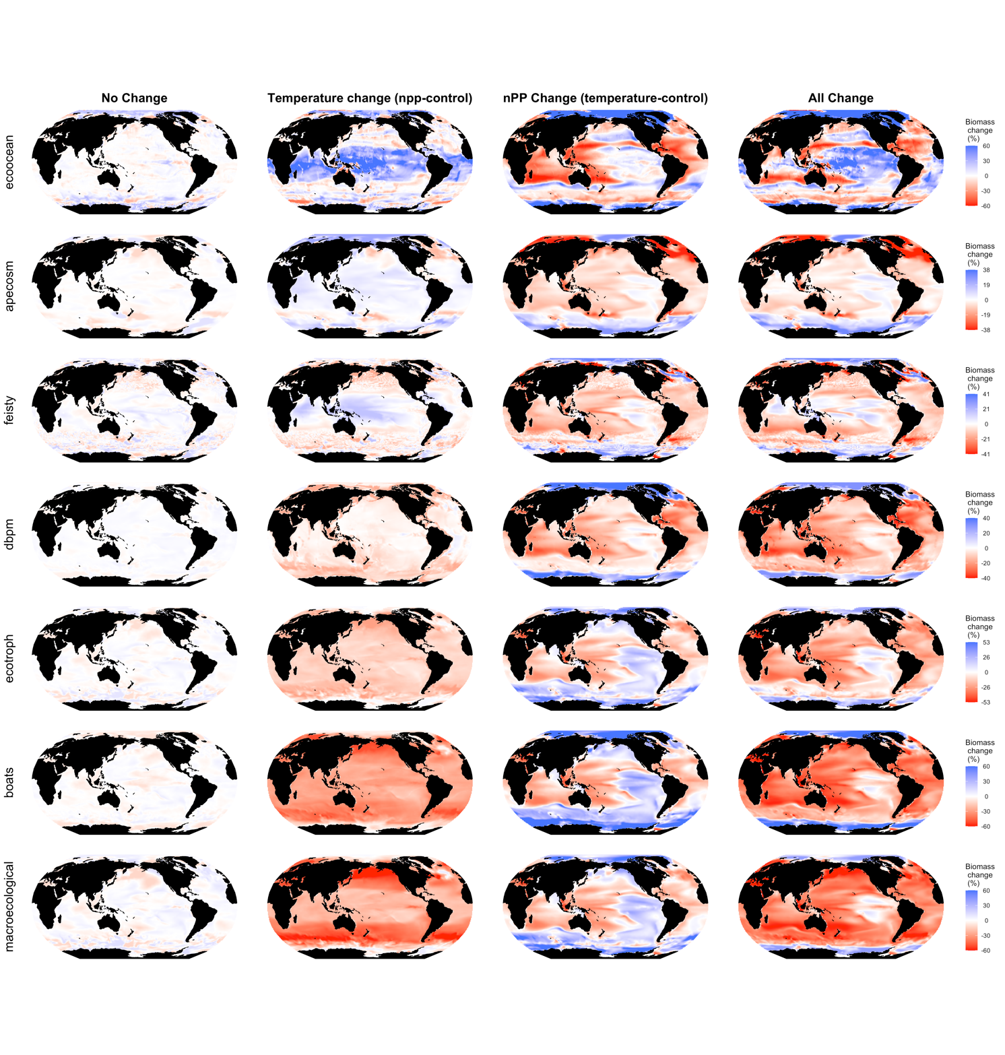

**Figure 2:** The change in total consumer biomass for each model under pi, npp-control, temp-control and climate change protocols, 1960-1970 vs. 2090-2100.

**NPP, temp, climate change impacts on community structure**

*** There’s a tonne of figures here, two for each model with each figure having 4-12 sub-figures. Need to think of how to summarise these results. See supplementary figures 3-17.

**How do npp-change impacts and temperature-change impacts interact in each model? Look at interaction between temperature and lower trophic level inputs in the models.**

**Figure 3:** % difference between climate-change and combined npp-change + sst-change on global biomass of organisms < 10cm, 10-30cm and >30cm and total organism biomass, relative to decadal mean of 1960-1970. Each line is calculated as climate-change impact – (npp-control impact + sst-control impact). Under dotted black line at 0%, climate-change impact < npp-change + sst-change impacts, indicating amplification of npp and sst effects when combined. Above dotted black line at 0%, climate change > npp-change + sst-change indicating attenation of npp and sst effects when combined.

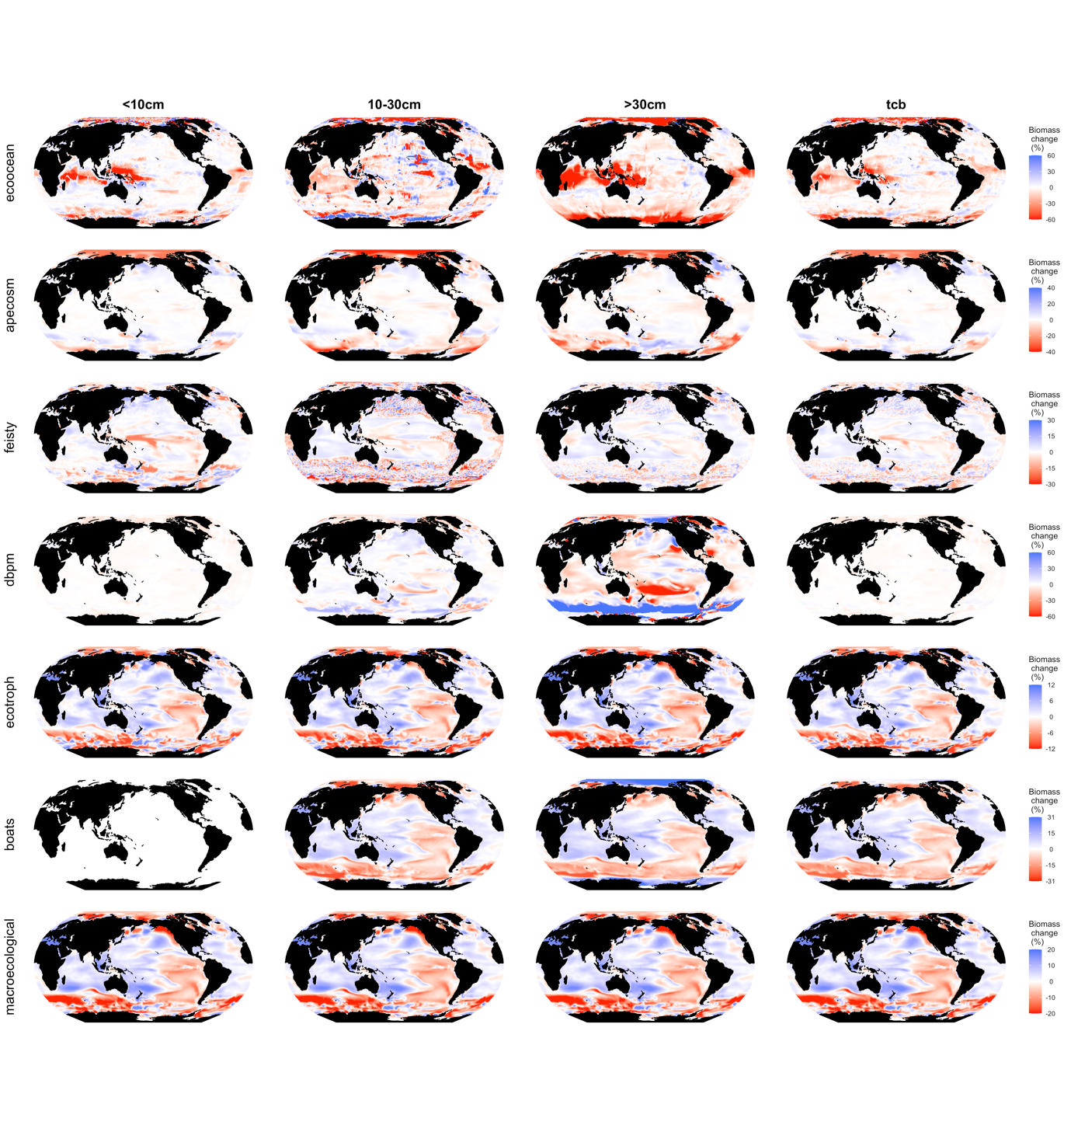

**Figure 4:** climate change – (npp-change + sst-change). Red areas show where npp-change+sst-change > climate-change (combined effects are attenuating leading to less extreme shifts in biomass), blue areas show were npp-change+sst-change < climate-change (combined effects amplify leading to more extreme shifts in biomass).

BOATS and MACROECOLOGICAL, which include temperature effect on representative size of phytoplankton see amplification of negative climate change impacts in regions where primary production increases (red regions in figure 4). Also attenuation of separate negative sst and npp impacts in regions where primary production decreases (blue regions in figure 4). Other models such as feisty, dbpm and apecosm also include change in size structure of phytoplankton or zooplankton with climate change, so temperature effects on lower trophic levels are implicitly included in these models from the inputs from esms. But, these implicit temp effects are already built in to lower trophic level inputs, so they are already present in the npp-change experiment. Run boats and macroecological without additional temperature effect on representative size of phytoplankton, these runs should look like ecotroph – very similar model but no change in phyto size structure. APECOSM, FEISTY and DBPM have slight trends in figure 3. These probably (?) can be explained by shifts in size structure of lower trophic level communities in response to temperature as well, these temperature effects are implicit in the esm output, biggest difference between clim change and npp+sst in APECOSM is in high latitudes, indicates negative amplification of npp and sst impacts.

EcoOcean…

**Which regions are most robust to model mechanism differences and why?**

*\*\* This section cannot lean too hard on spatial distribution of agreement/disagreement, since this depends on the earth system model we have used. We need to contextualise changes by looking at environmental conditions in areas of agreement and disagreement, in order to generalise under what conditions model agree/disagree most. That’s what figure 6 would be for.*

**Figure 5:** Global map of model agreement on direction of change, for npp-control, sst-control and climate change runs

**Figure 6:** Environmental conditions where models agree/disagree most.

**Comparison of model results with Free et al. 2019 data**

**Figure 7:** Comparison of models results with data.

**DISCUSSION**

Nutrient limitation – no models really consider this. Compare with iron-limited BOATS.

Lower trophic level processes. Figure 5 in Stock et al., 2005.

We are lacking a continual understanding of temperature effects that extend from the molecular scale to the ecosystem scale.

**SUPPLEMENTARY**

Supplementary Figure 1: Global integral plots of delta change in environmental variables through time under hist+rcp85

Supplementary Figure 2: Global maps of delta change in environmental variables (1960-1960 vs 2090-2100)

Supplementary Figure 4: Maps of delta total biomass change in

Supplementary Figure 3-17: Maps of delta <10cm, 10-30cm and >30cm biomass for each model, facilitate discussion of trophic interactions

**Supplementary Table 1** Earth system model forcings that are required as environmental drivers for each of the global models.

|  |  |  |  |
| --- | --- | --- | --- |
| **Model** | **Temperature-related forcings** | **Lower trophic level-related forcings** | **Other environmental forcings** |
| APECOSM | Depth-resolved water temperature | Depth-resolved small and large phytoplankton and zooplankton biomass | Depth-resolved dissolved oxygen concentration, photosynthetically active radiation (light), large particulate organic carbon, and longitudinal and latitudinal current velocities |
| BOATS | Mean water temperature (top 75m) | Depth integrated phytoplankton production | - |
| DBPM | Sea surface and floor water temperature | Depth integrated small and large phytoplankton biomass | - |
| EcoOcean | Mean water temperature | Depth integrated small and large phytoplankton biomass and diazotroph biomass | - |
| EcoTroph | Sea surface water temperature | Depth integrated phytoplankton production | - |
| FEISTY | Sea surface and floor water temperature | Depth integrated small and large zooplankton biomass, export carbon flux to sea floor | - |
| SS-DBEM | Sea surface and floor water temperature | Depth integrated phytoplankton production | Sea surface and floor dissolved oxygen concentration, pH and salinity; surface sea ice concentration, longitudinal and latitudinal current velocity |
| Macroecological | Sea surface water temperature | Depth integrated phytoplankton production | - |

**Supplementary Table 2** Summary of conversion equations for model outputs

|  |  |  |  |
| --- | --- | --- | --- |
| Model | Native biomass | Conversion coefficients from native biomass to carbon | Conversion equations from native biomass to length |
| APECOSM | Joules |  |  |
| BOATS | Wet biomass | 0.1 |  |
| DBPM | Wet biomass | 0.0352 |  |
| EcoOcean | Wet biomass |  |  |
| EcoTroph | Wet biomass |  |  |
| FEISTY | Wet biomass | 0.12 |  |
| MACROECOLOGICAL | Wet biomass | 0.0352 |  |